SVG element xpath

//\*[local-name()='svg' and @viewBox="0 0 570.72284 1144.08619"]

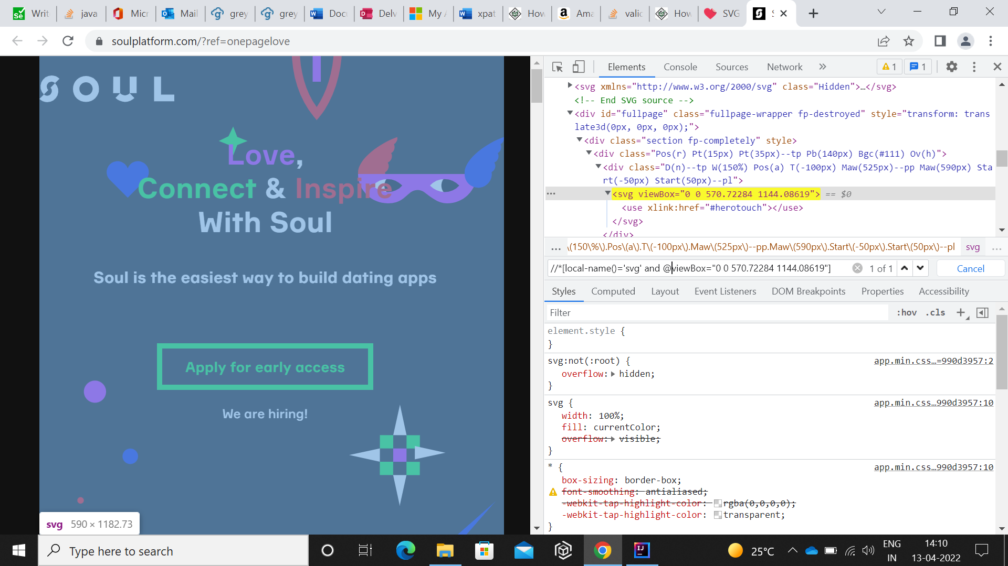

Example of xpath of elements that disappears after a short span of time

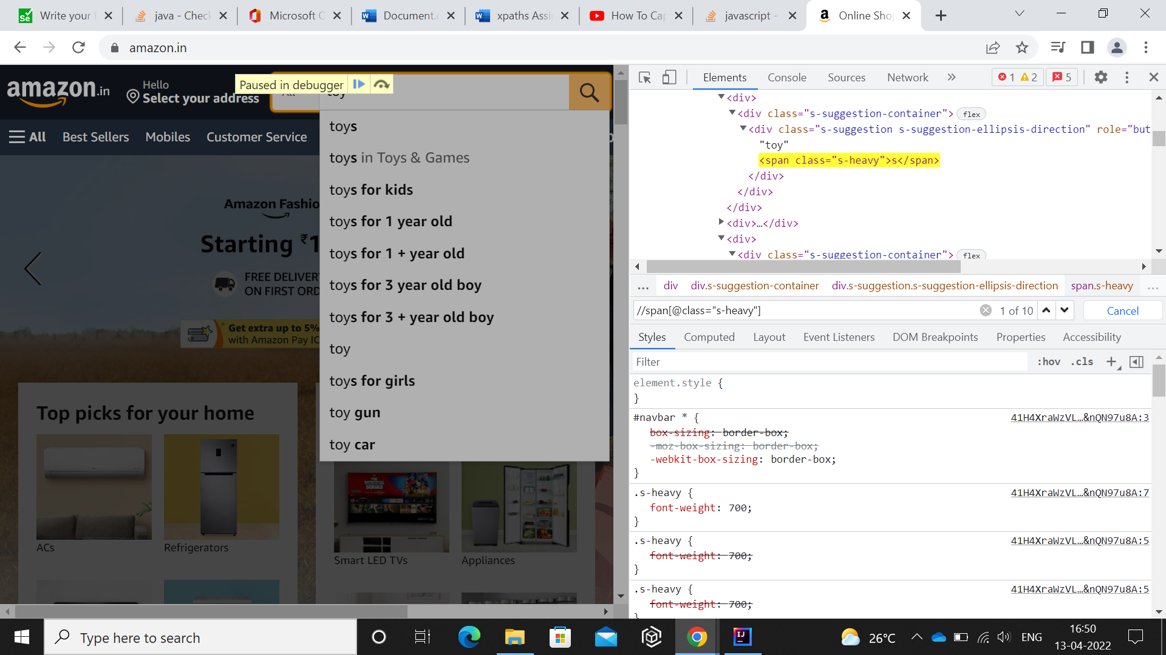

Qn: Why do we need axes methods to create xpaths? Try to create different xpaths using axes methods

Ans: XPath axes help to find elements based on the element’s relationship with another element in an XML document.

Xpath: //div[@class="controls"]/child::select

